**Module 3: Policy Assignment-2**

**Problem Statement**

You work for XYZ corporation to maintain the security of the AWS account and the resources you have been asked to implement a solution that can help easily recognize & different users.

**You have been asked for:**

1. Create a policy number 1 which lets the user to

a. Access S3 Completely

b. Only create EC2 Instance

c. And full access to RDS

2. Create a policy number 2 which lets the user to

a. Access Cloud Watch & Billing Completely

b. And can only list EC2 & S3 resources completely.

3. Attach policy number 1 to DevTeam from task 1.

4. Attach policy number 2 to OpsTeam from task 1.

**Problem Solution 1:**

**a. Access S3 Completely**

**Step 1: Search** the **“IAM”** option **first.**

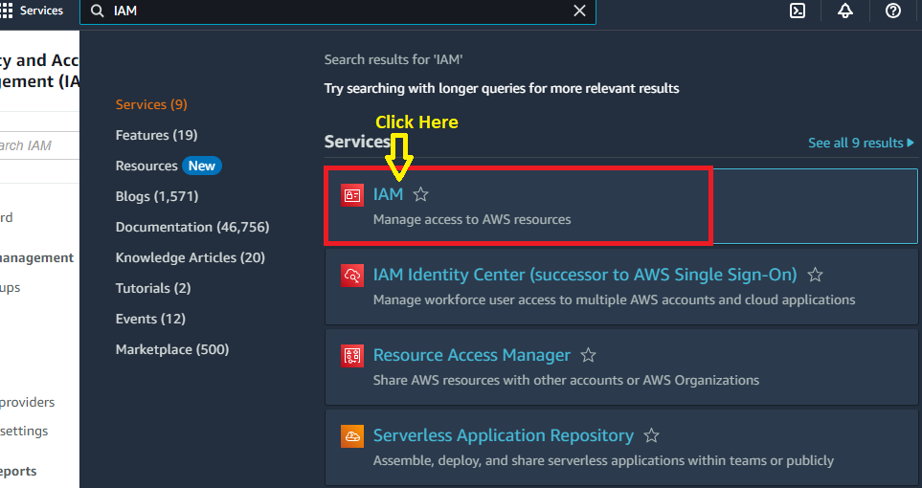

**Step 2: Go** tothe **“Policies”.**

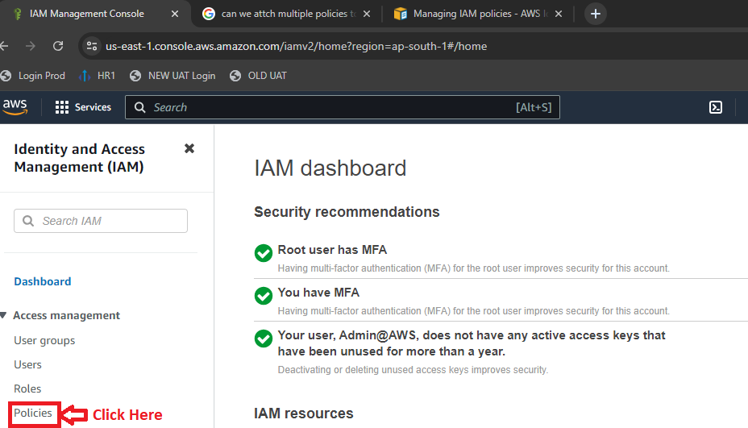

**Step 3: Click** onthe **“Create Policy”.**

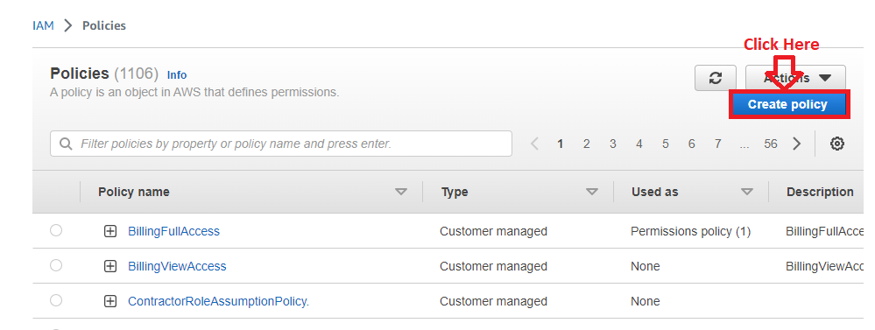

**Step 4:** Inthe **“Visual”, choose** the **“s3” option** by **clicking** it**.**

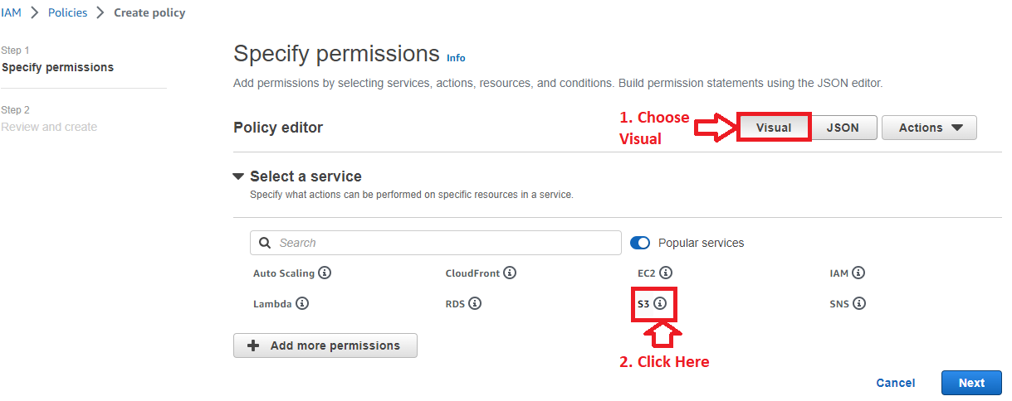

**Step 5:** In **the S3** option**, Right Tick** onthe **“All S3 actions (s3:*)”. All access** would be **selected.**

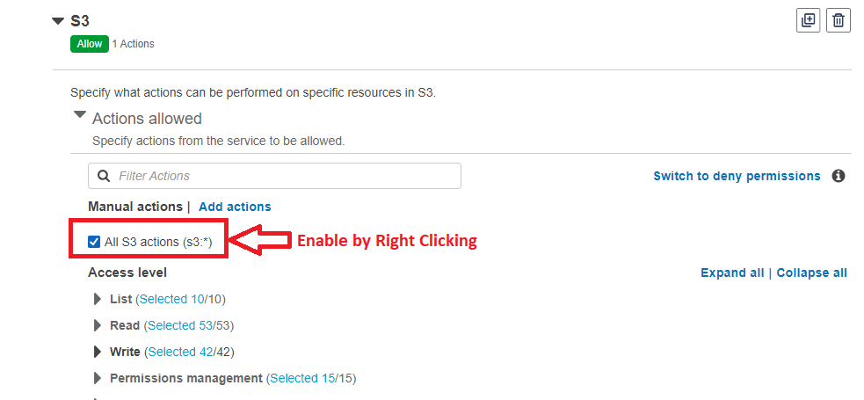

**Step 6: Choose “All”** in the **“Resources”** section.

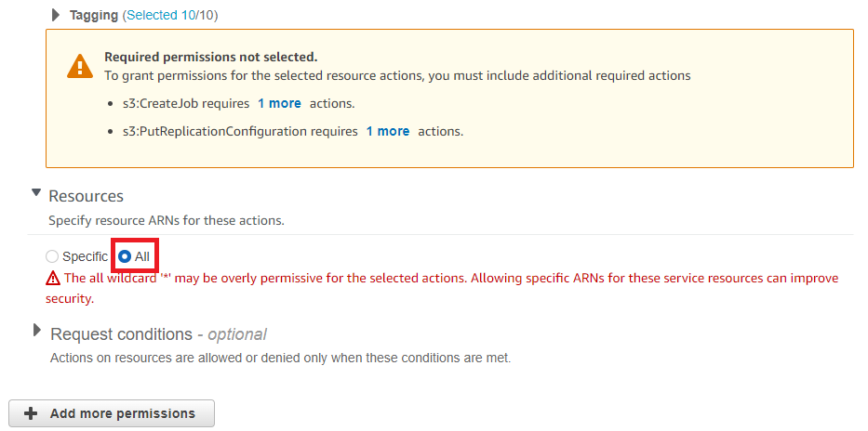

**b. Only Create EC2 Instance**

**Step 1:** In **last step, click** onthe **“Add More Permissions”.**

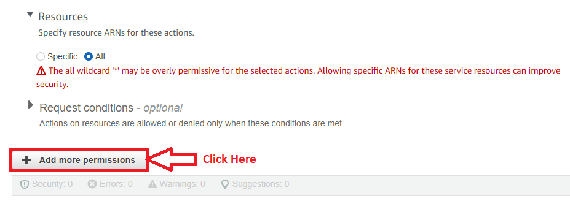

**Step 2: Click** onthe **“Select a Service”.**

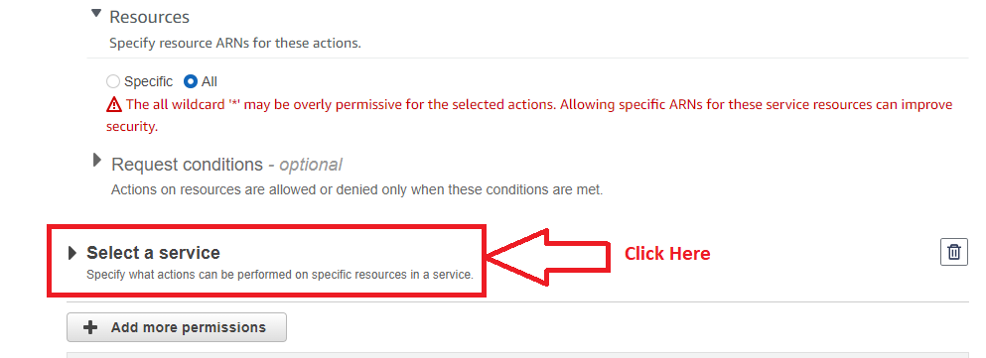

**Step 3: Choose** the **“EC2”** here**.**

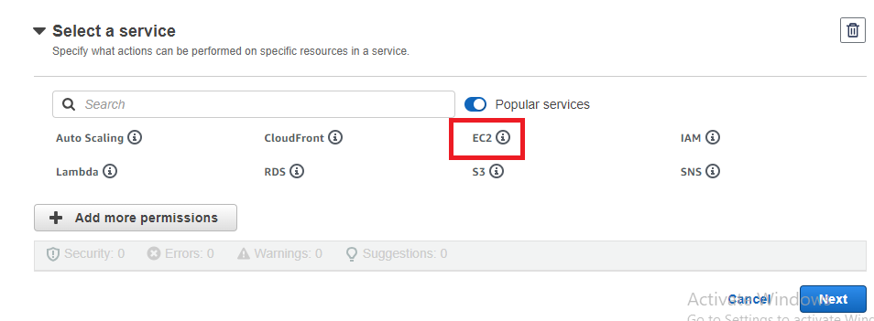

**Step 4:** In the **“Access Level”, Go** tothe **“List”** by **clicking** on **it.**

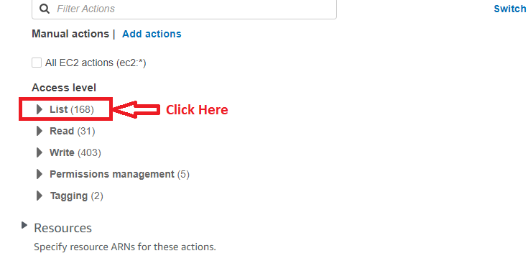

**Step 5: Choose** the **Following Entries** in the **“Lists”** section**;**

1. DescribeAccountAttributes
2. DescribeAddresses
3. DescribeAddressesAtributes
4. DescribeAvailabilityZones
5. DescribeHosts
6. DescribeImages
7. DescribeImageAttributes
8. DescribeKeyPairs
9. DescribeSecurityGroups
10. DescribeSecurityGroupRules
11. DescribeSubnets
12. DescribeVpcs
13. DescribeVpcEndpoints
14. DescribeTags
15. DescribeInstances
16. DescribeInstanceAttribute
17. DescribeInstanceStatus
18. DescribeInstanceTypes
19. DescribeRegions
20. DescribeRouteTables
21. DescribeNetworkInterfaces
22. DescribeVolumes

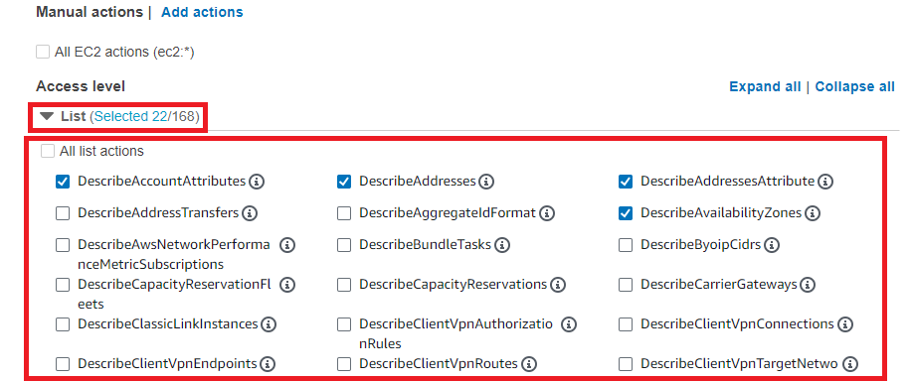

**Step 6: Choose** the **Following Entries** inthe **“Write”** section**;**

a**.** Attach Volume

b. Create Volume

c. Delete Volume

d. Allocate Hosts

e. CreateVpc

f. DeleteVpc

g. Create KeyPair

h. Delete KeyPair

i. AuthorizeSecurityGroupEgress

j. AuthorizeSecurityGroupIngress

k. CreateDefaultVpc

l. CreateDefaultSubnet

m. CreateRoute

n. CreateRouteTable

o. CreateSecurityGroup

p. CreateSubnet

q. DeleteRoute

r. DeleteRouteTable

s. DeleteSecurityGroup

t. Delete Subnet

u. StartInstances

v. StopInstances

w. RunInstances

x. RevokeSecurityGroupEgress

y. RevokeSecurityGroupIngress

z. TerminateInstances

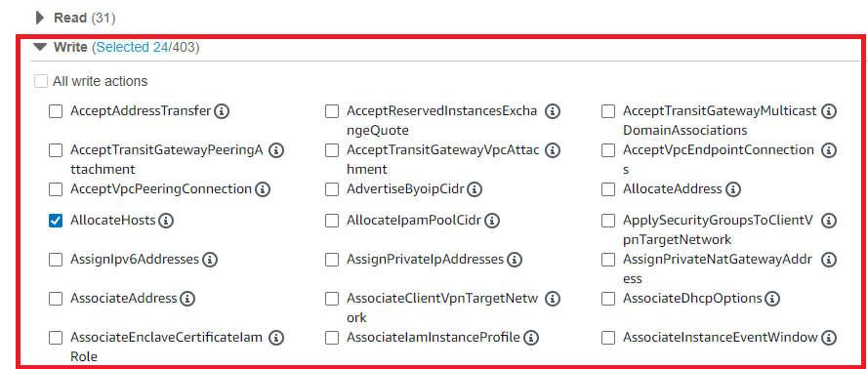

**Step 7:** Choose the “**All** **tagging actions”** in the **“Tagging”** option.

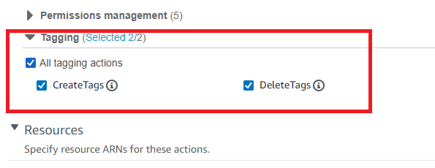

**Step 8:** Choose the **“All”** option in the **“Resources”**.

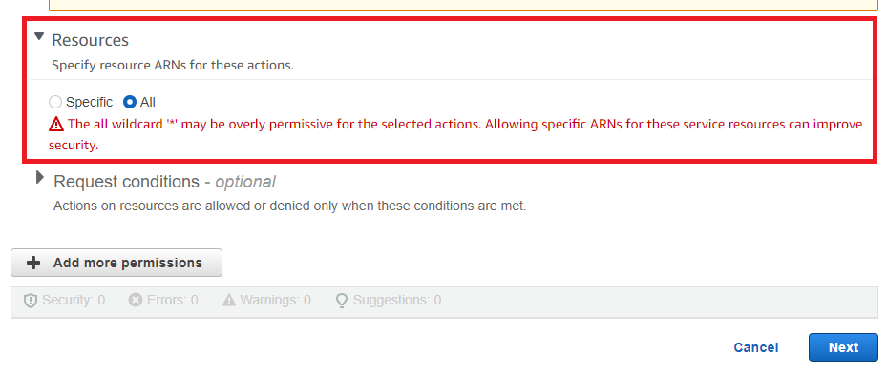

**c. Full Access to RDS**

**Step 1: Click** onthe **“Add more permissions”.**

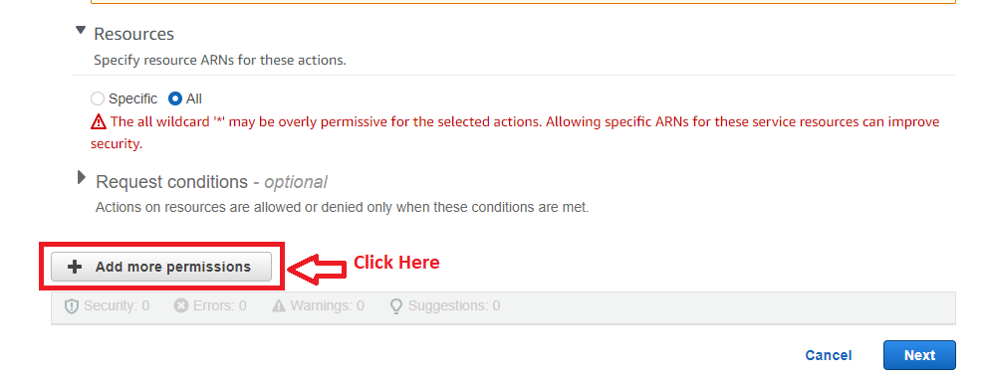

**Step 2: Click** on the **“Select a Service”** option.

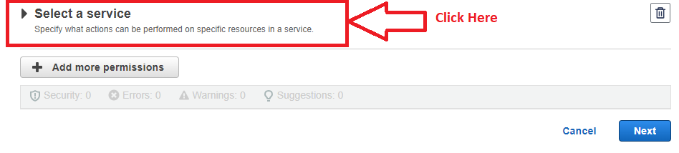

**Step 3: Click** on the **“RDS”.**

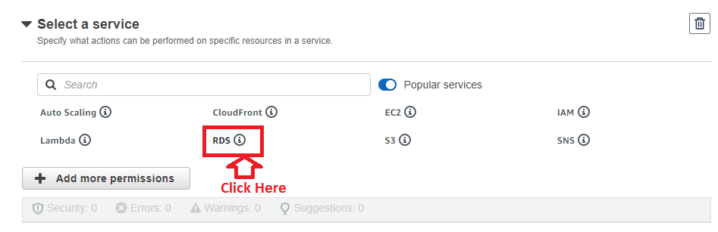

**Step 4: Choose** the **“All RDS Actions”**.

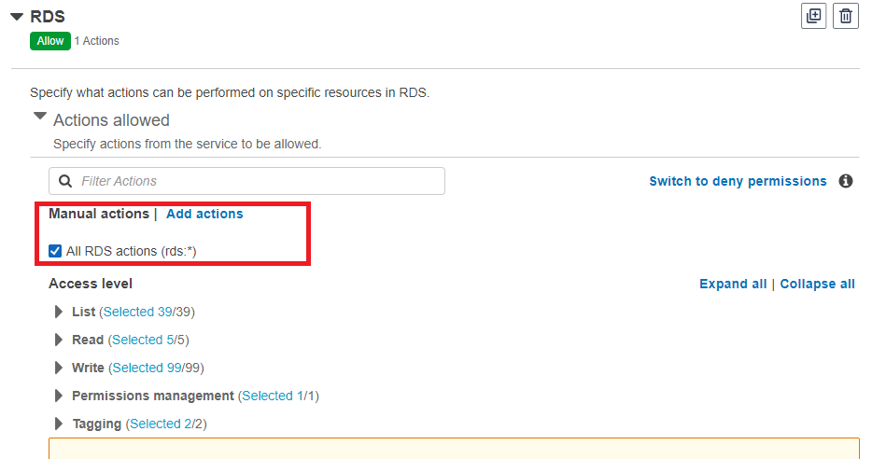

**Step 5:** Choose **“All”** in the **“Resources”** section.



**Step 6: Click** on **“Next”**.

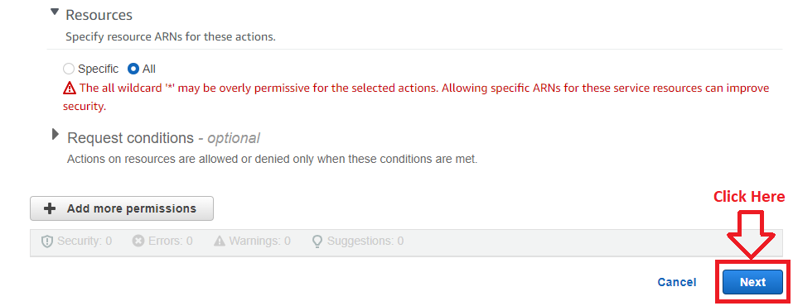

**Step 7: Put** the **“PolicyNumber1”** as the **name** inthe **“Policy Name”.**

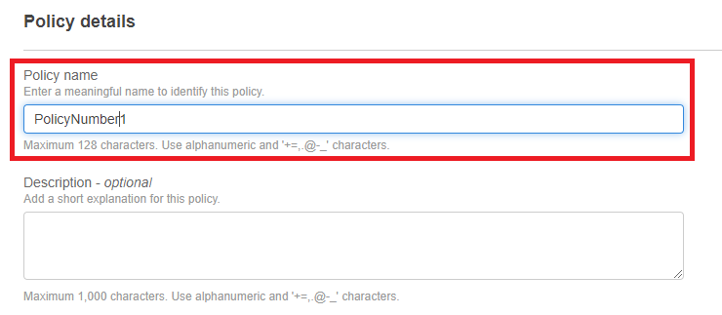

**Step 8: Click** on the **“Create Policy”**.

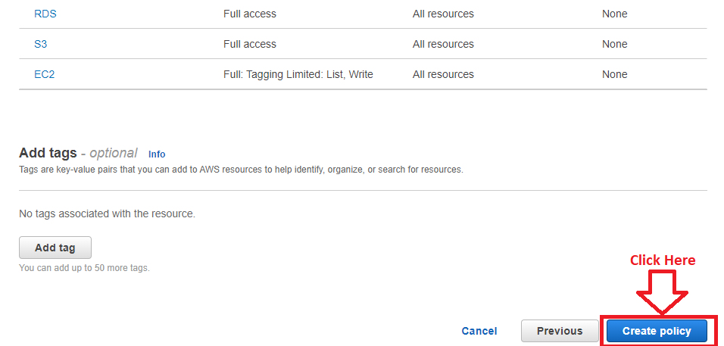

**Step 9: The policy [PolicyNumber1]** will be **successfully created.**

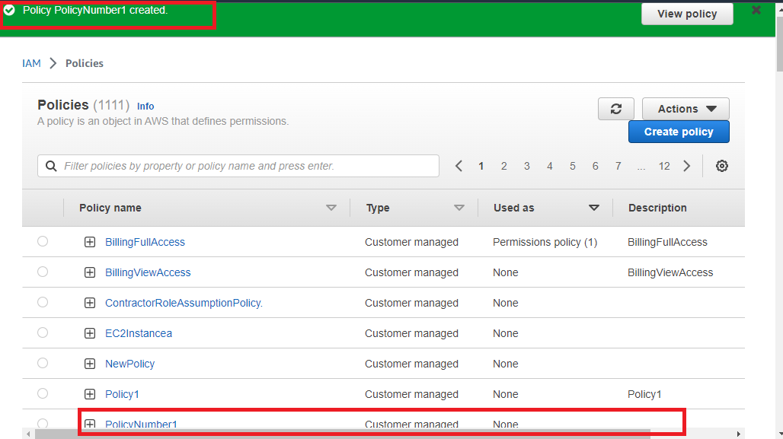

**The “PolicyNumber1” policy** hasbeen **successfully created** now**.**

**Problem Solution 2:**

**a. Access CloudWatch & Billing Completely**

**Step 1: Go** to the “**Policies”** option.

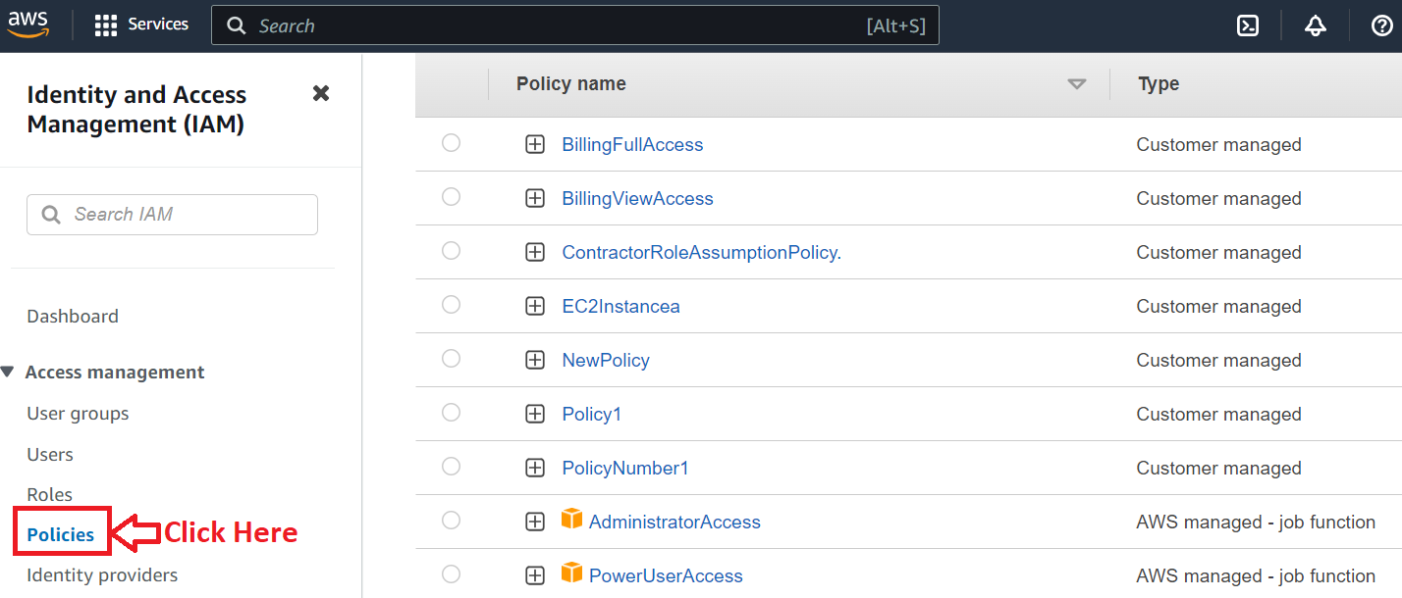

**Step 2: Click** on the “**Create policy”.**

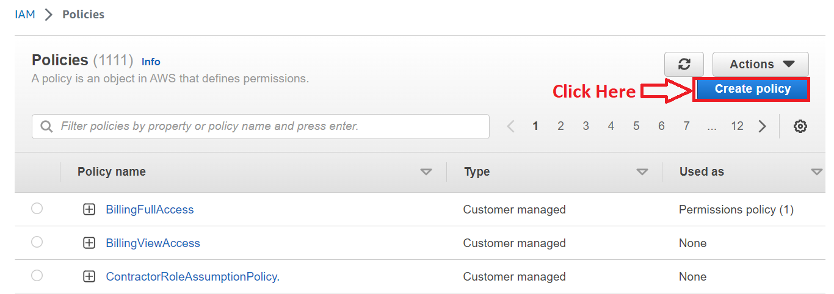

**Step 3: In** the **“Select a Service”** section**, search** the **“CloudWatch”** service**. Click** on the “**CloudWatch.”**

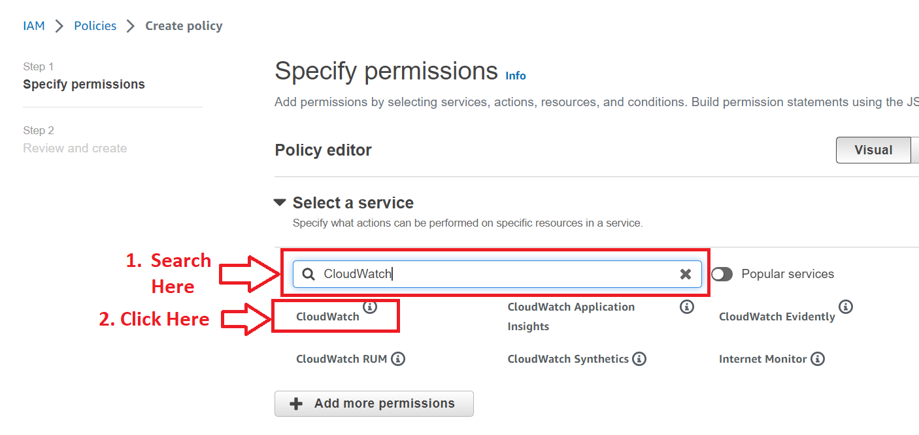

**Step 4:** **Apply** the **right tick** on the “**All CloudWatch actions (cloudwatch:*)” in** the **“Manual Action”.** In the **“Resources”, Choose** the **“All” option.**

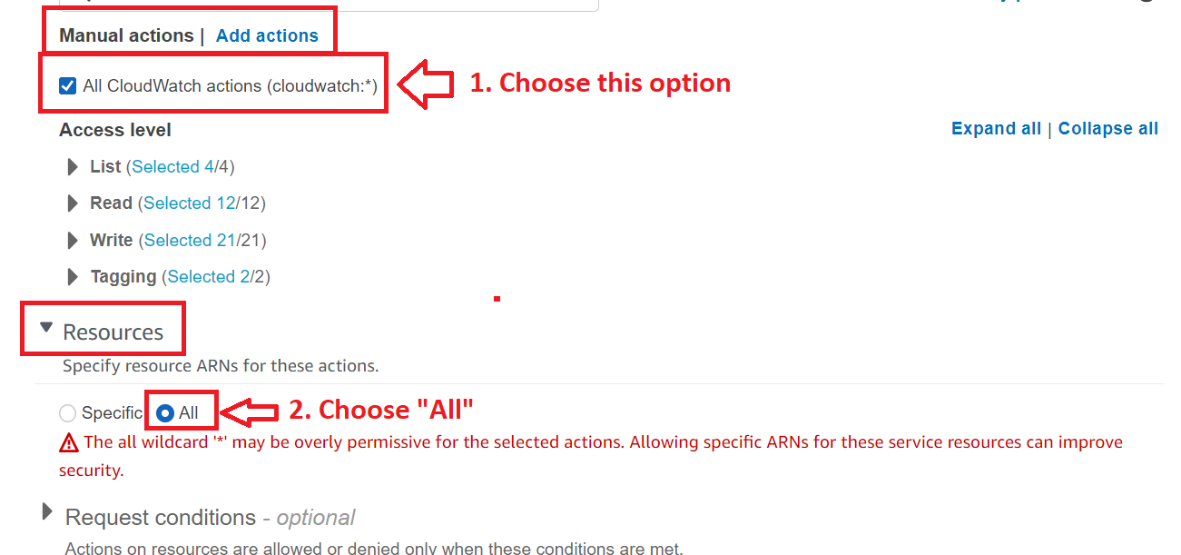

**Step 5: Click** on the **“Add More Permissions”.**

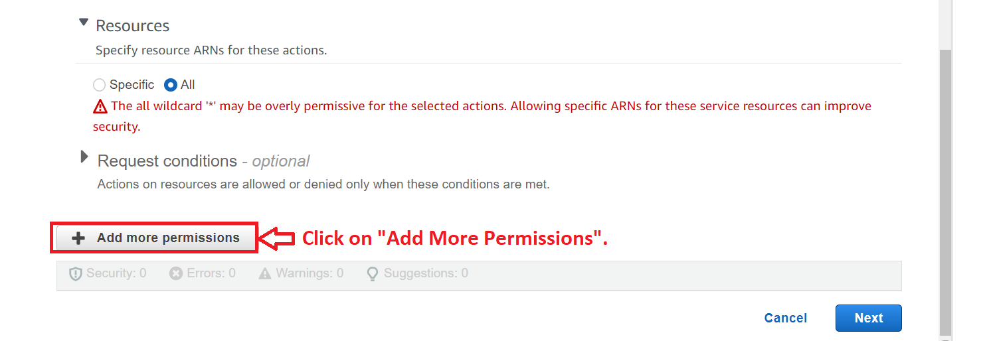

**Step 6: Click** onthe **“Select a Service”** option.

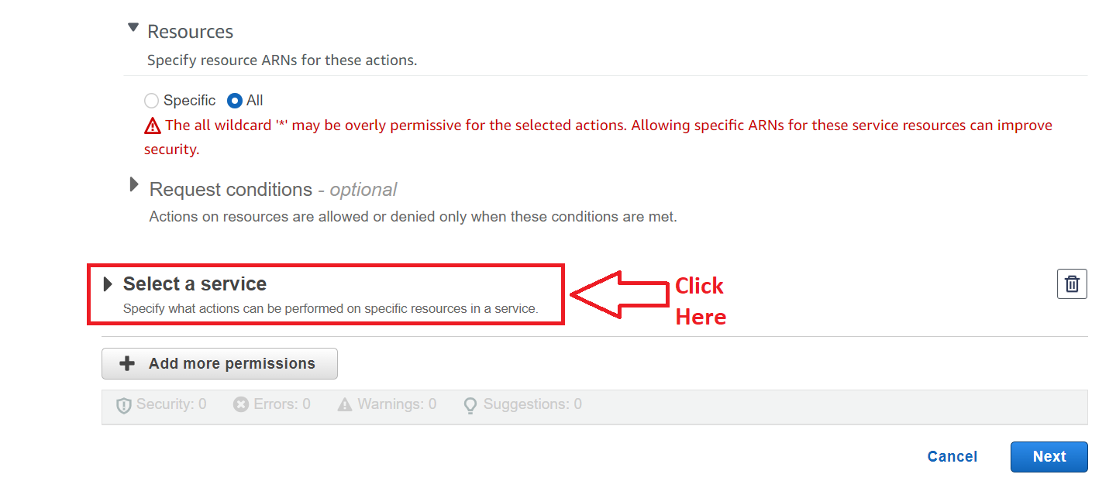

**Step 7: Search** the **“Billing”** option& **select** the **“Billing”** option.

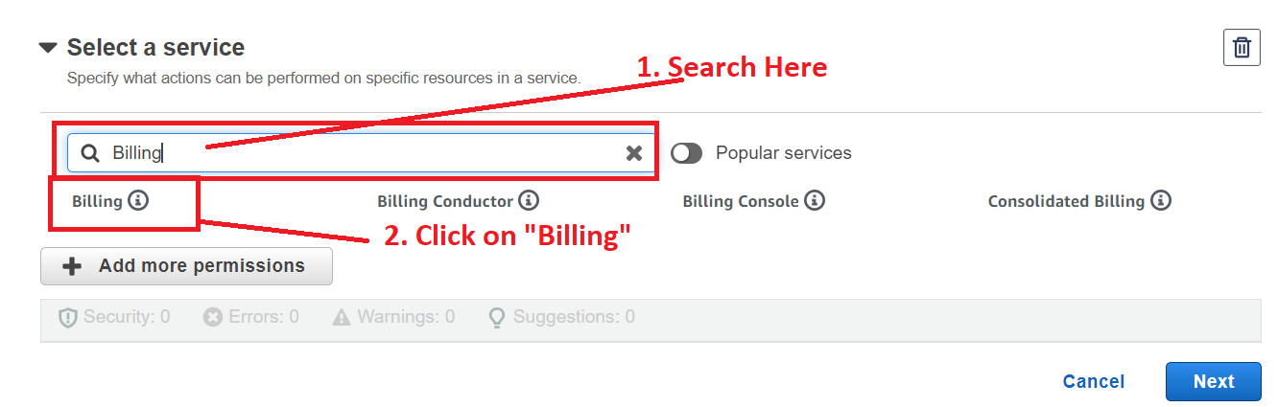

**Step 8: Choose “All Billing actions (billing:*)”** inthe **“Manual Actions”. In** the **“Resources”, Choose “All”.**

**Click** onthe **“Next”.**

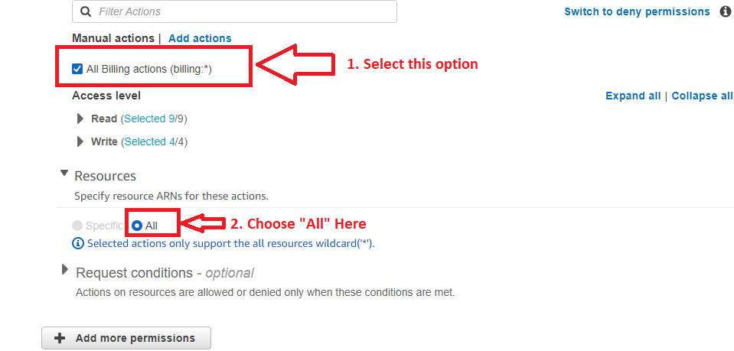

**Click** on the **“Next”**.

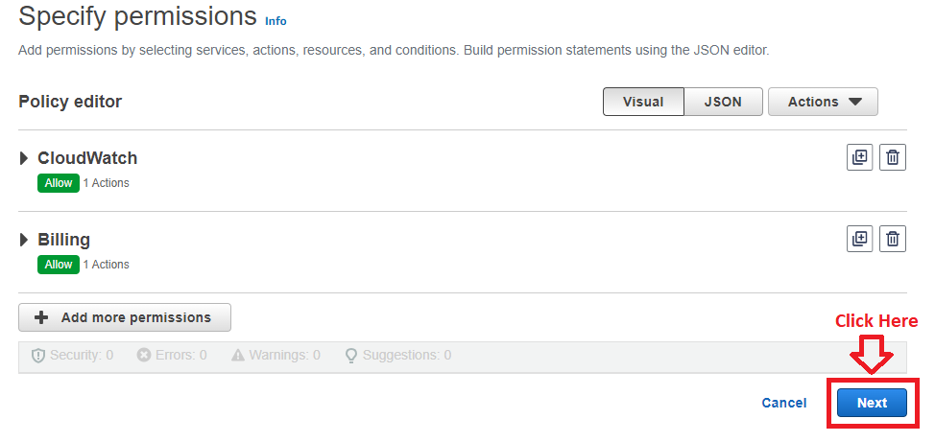

**Step 10: Put** the **“Policy Name”** asthe **“PolicyName2”.**

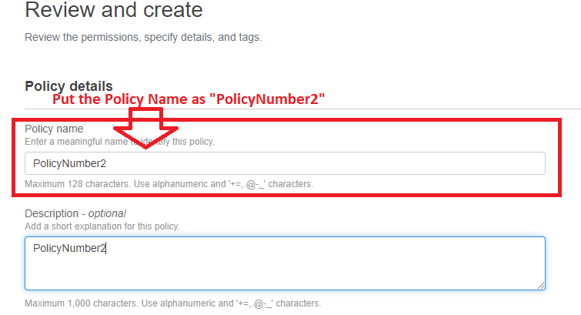

**Step 11: Click** onthe **“Create Policy”.**

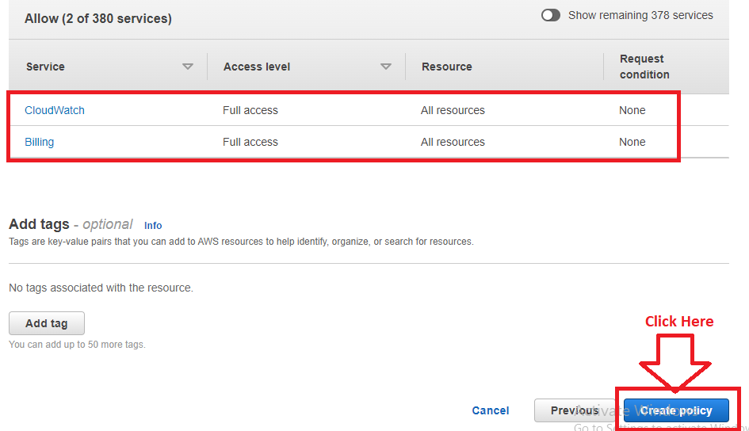

**Step 12:** The **“PolicyNumber2”** will be **successfully created.**

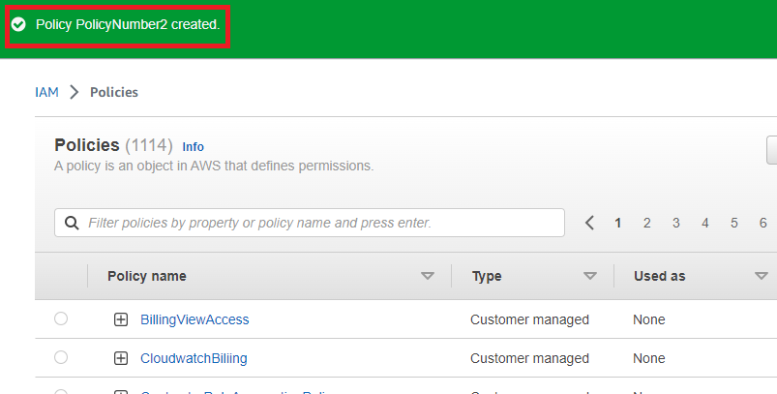

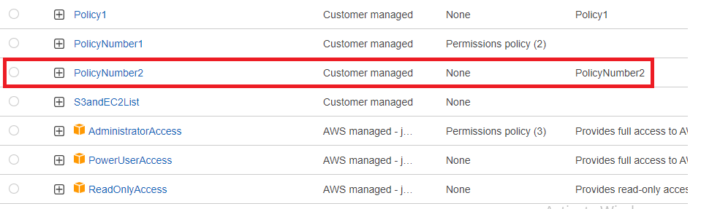

***Note:*** *We are creating these policies separately because we are facing the character’s limit issues, if created together.*

**b. And can only list EC2 & S3 resources completely.**

**Step 1: Click** on the **“Create policy”**.

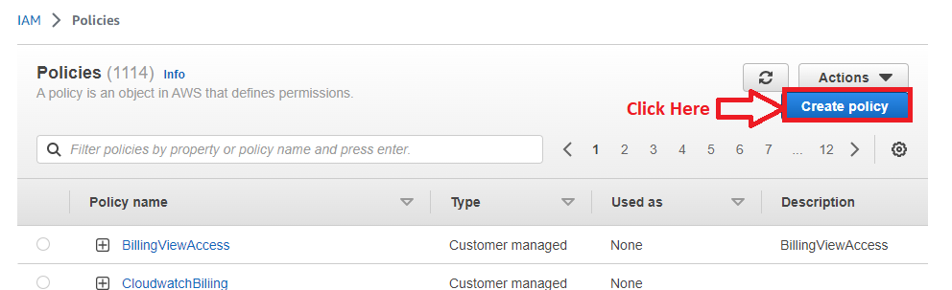

**Step 2: Click** on the **“Select a Service”**.

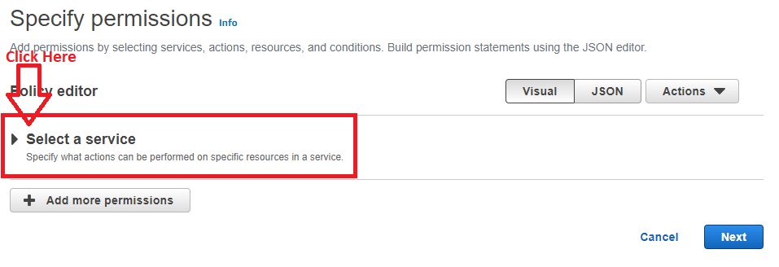

**Step 3: Select** the **“EC2”.**

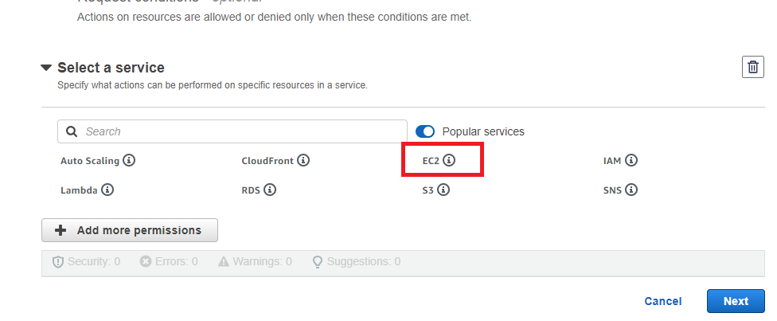

**Step 4: Click** onthe **“List”** inthe **“Access Level” section.**

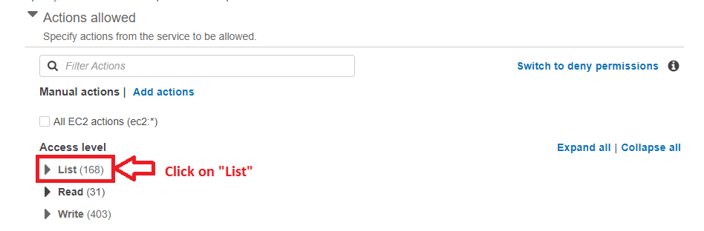

**Step 5: Select** the **“All list actions”. All** the **list actions** will be **selected.**

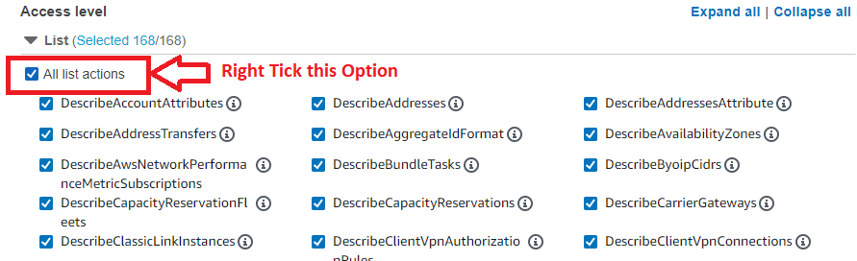

**Step 6: Choose** the **“Resources” option** as **“All”.**

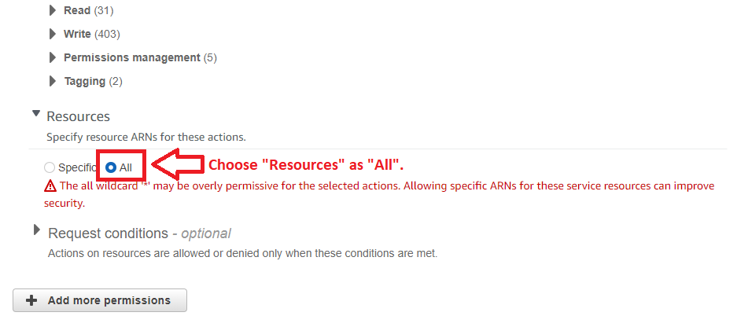

**Step 7: Click** on the **“Next”.**

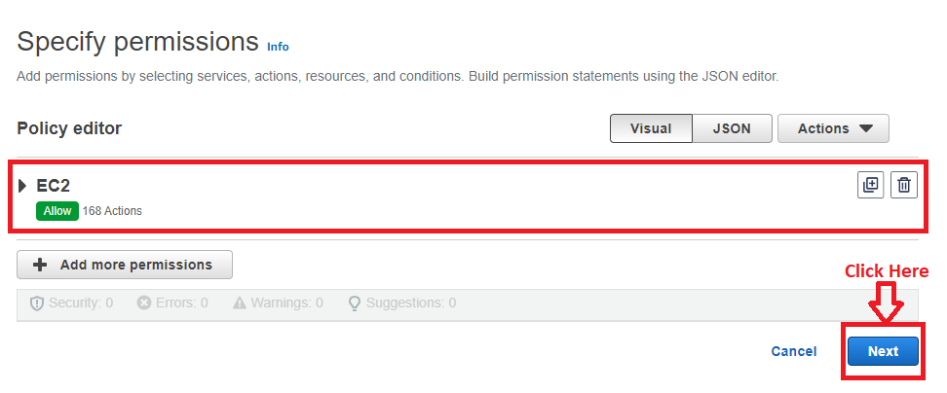

**Step 8: Write** the **“PolicyName”** as **“PolicyName3”.**

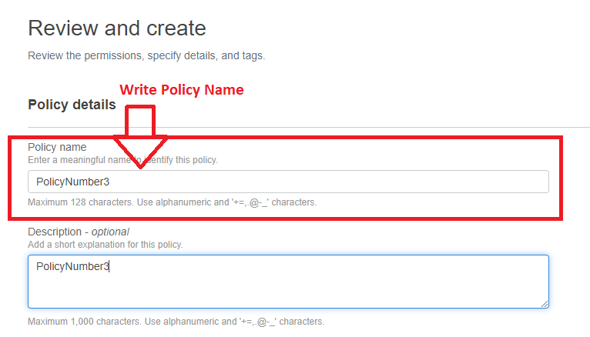

**Step 9: Click** on the **“Create Policy”.**

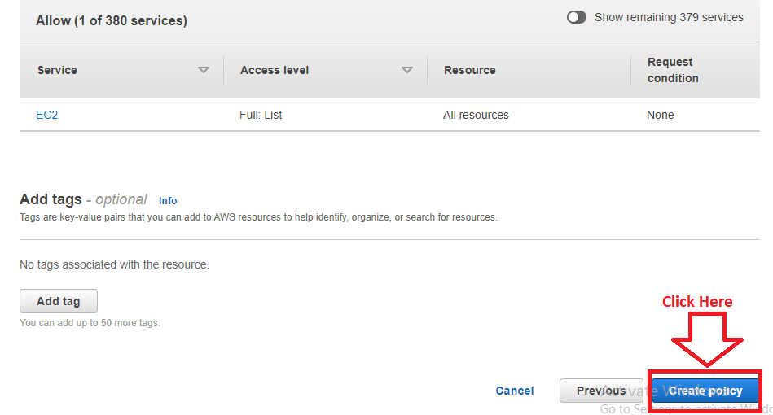

**Step 10: The “PolicyNumber3”** will be **successfully created.**

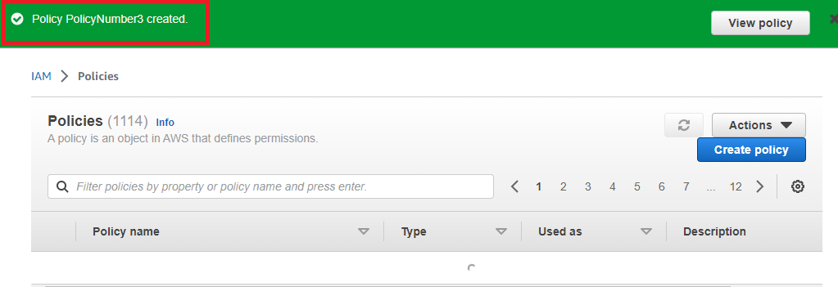

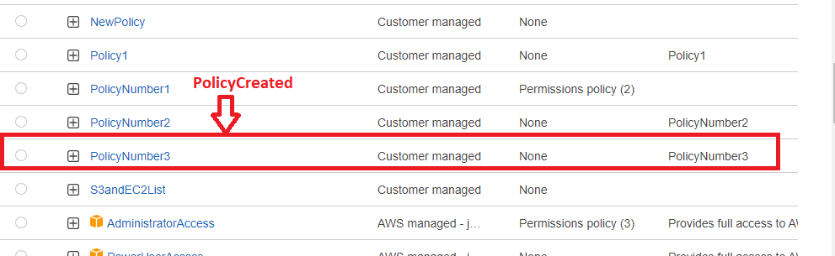

**Step 11: Again, click** onthe **“Create policy”.**



**Step 12: Choose** the **“S3”** as a **service.**

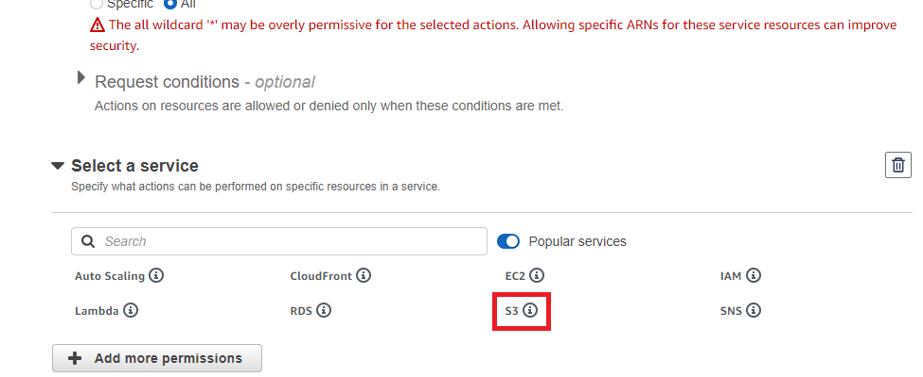

**Step 13: Go to** the **“List” option** & **choose** the **“All list actions”.**

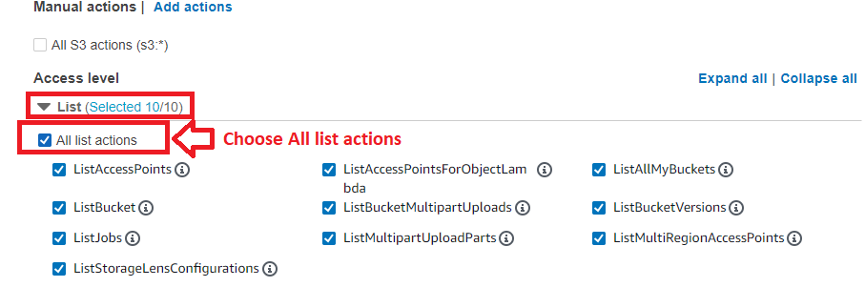

**Step 14: Choose** the **“Resources”** as **“All”. Click** onthe **“Next”.**

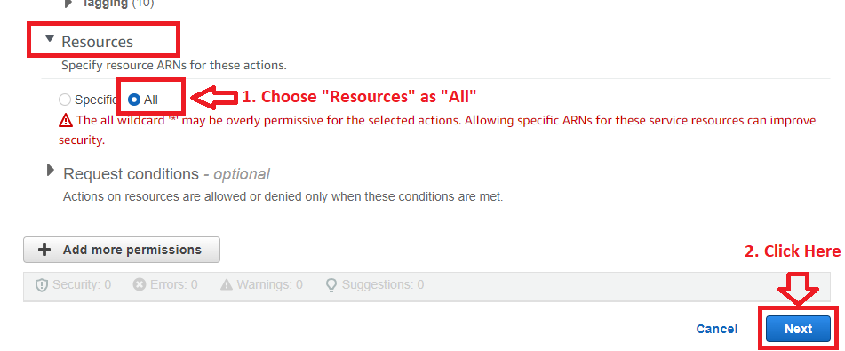**Step 15: Write** the **“Policy Name”** as **“PolicyNumber4”.**

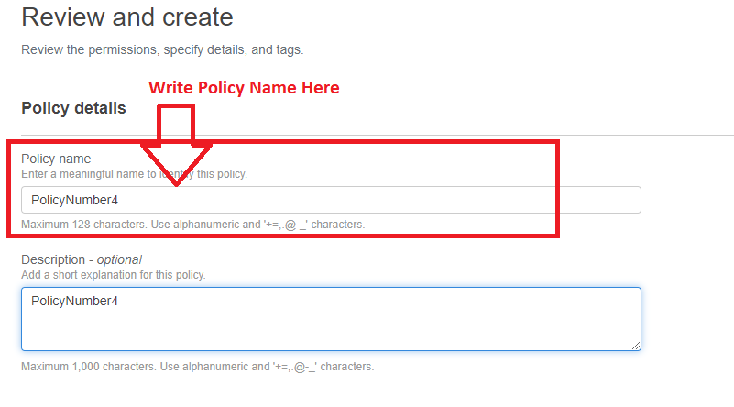

**Step 13: Click** onthe **“Create Policy”.**

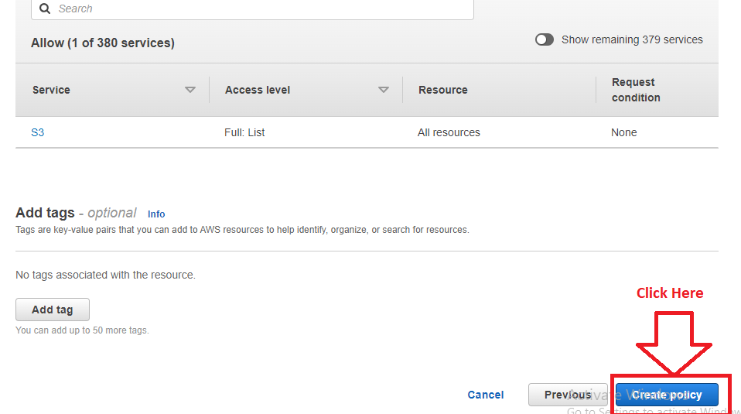

**Step 14:** The **“PolicyNumber4”** as a **policy** will be **successfully created.**

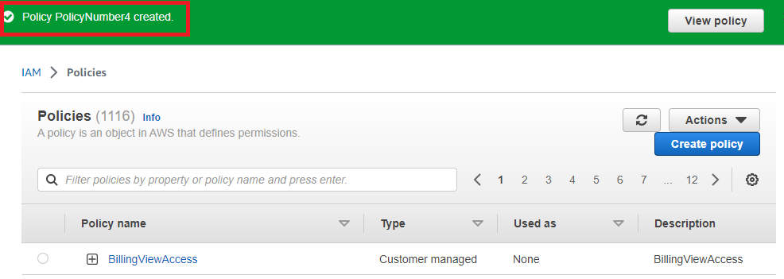

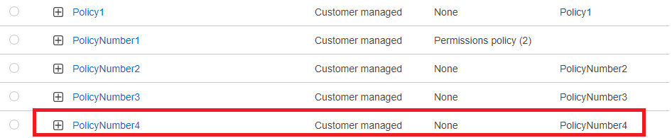

**So,** the **cloudWatch** & **billing policy** with **listing EC2 & S3** is **created successfully** in the **PolicyNumber2 (CloudWatch & Billing), PolicyNumber3 (EC2), PolicyNumber4 (S3).**

**Problem Solution 3*: Attach policy number 1 to Dev Team from task 1.***

**Step 1: Go** tothe **“User Groups”** & **click** on the **“DevTeam”** user group**.**

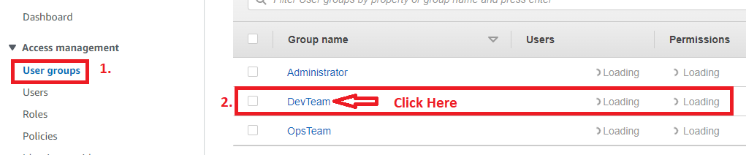

**Step 2: Go** to the **“Permissions>Add Permissions”.**

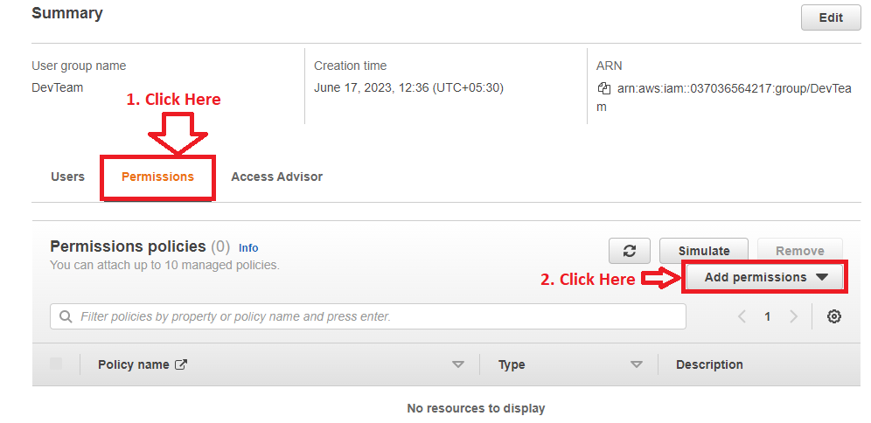

**Step 3: Click** on the **“Attach Policies”.**

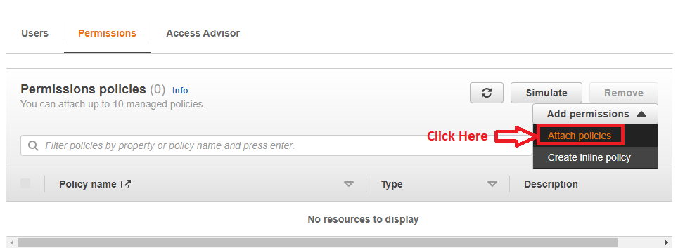

**Step 4: Choose** the **“PolicyNumber1”.**

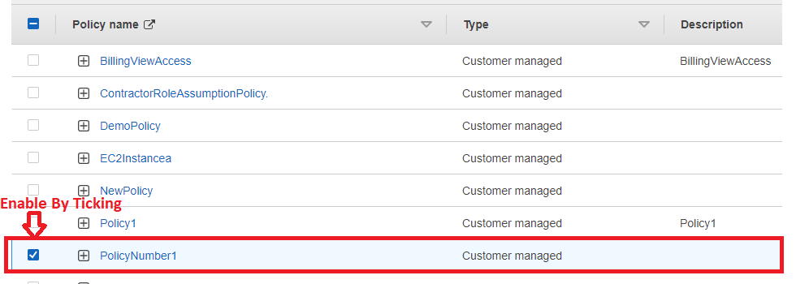

**Step 5: Click** onthe **“Add Permissions”.**

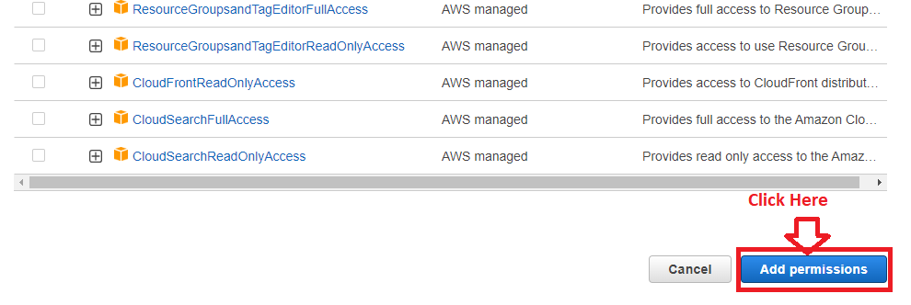

**Step 6: The “PolicyNumber1”** will be successfully **attached** tothe **“DevTeam”.**

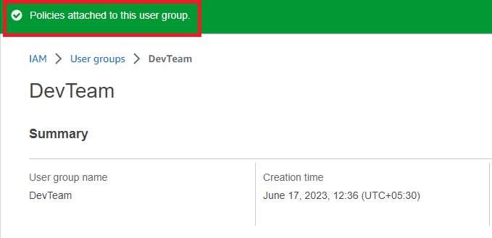

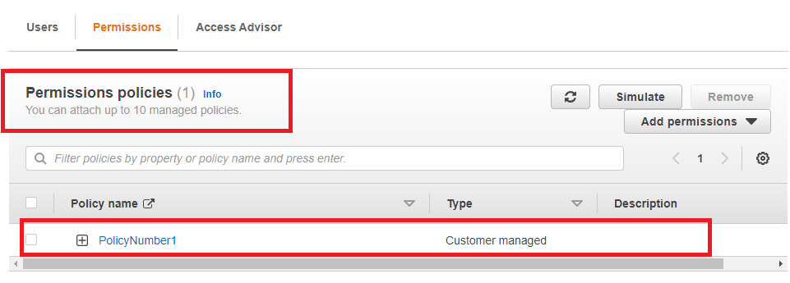

**Problem Solution 4*: Attach policy number 2,3,4 to Ops Team from task 1.***

**Step 1: Go** tothe **“Users groups>OpsTeam”.**

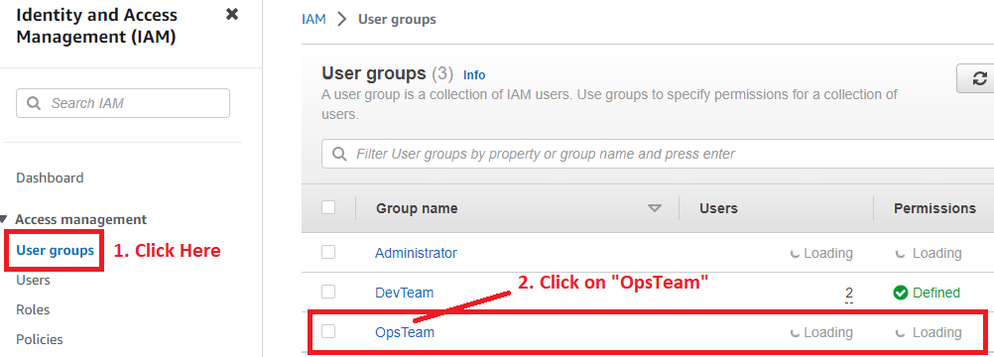

**Step 2: Go** to the **“Permissions>Add Permissions”.**

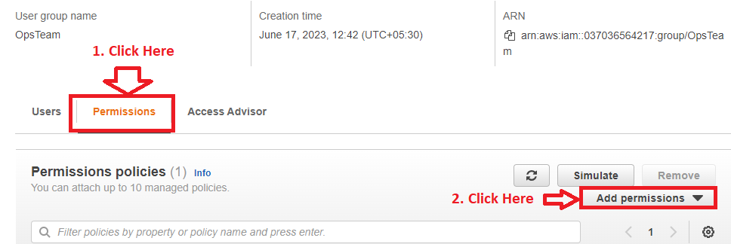

**Step 3: Click** onthe **“Attach Policies”.**

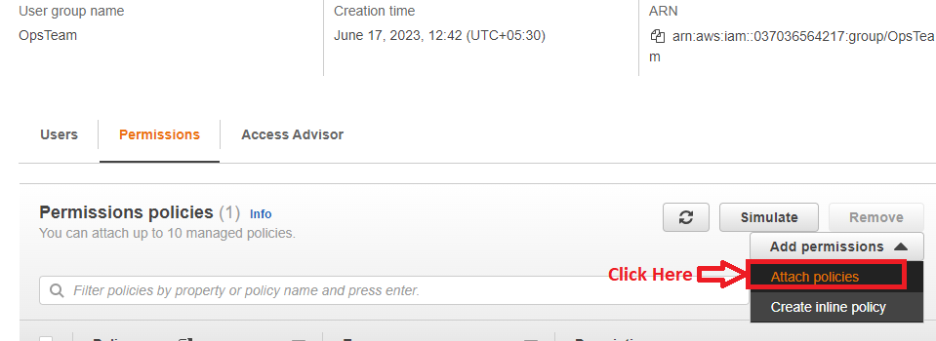

**Step 4: Choose** the **“PolicyNumber2, PolicyNumber3, PolicyNumber4”.**

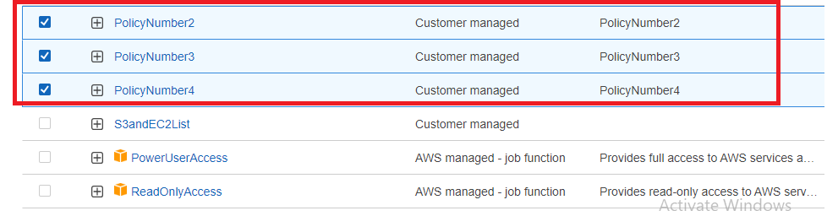

**Step 5: Click** on the **“Add Permissions”.**

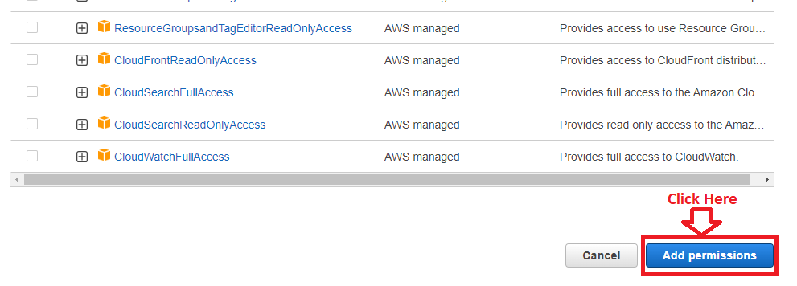

**Step 6:** The **“PolicyNumber2, PolicyNumber3, PolicyNumber4” attached** with **“OpsTeam”** successfully**.**

